S&T Anticipatory Threat Analysis Cell (ATAC)

*“As you well know, many of the technologies that might be associated with a new offset strategy - robotics; autonomous operating, guidance and control systems; visualization; biotechnology; miniaturization; advanced computing and big data; and additive manufacturing like 3-D printing - are being driven by the commercial sector.”*

*Deputy Secretary of Defense, Bob Work*

*15 March 2015*

Globalization and the proliferation of capital markets around the world have led to important S&T developments *and* increasing transparency in places that before were opaque at best. MITRE’s Anticipatory Threat Analysis Cell exploits the fact that the commercial and financial sectors not only drive but *track* global S&T developments in increasing detail. The ATAC draws upon MITRE S&T and IT expertise, and a unique complement of data to provide situational awareness and trend analysis on emerging and existing science and technologies.

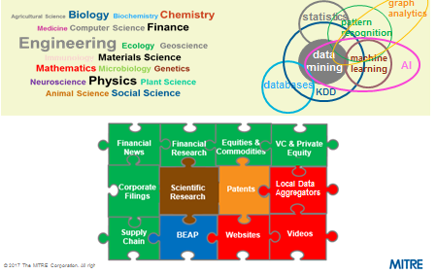

The ATAC analyzes traditional research, patent, industry and native language www sources and works with leading financial vendors to demonstrate the utility of an approach that combines the traditional sources with an ever expanding array of financial sources to provide more current, resolute and sophisticated understanding. The ATAC approach uncovers important “intelligence” from analyzing these sources and also provides commercial baselines that allow for richer understanding of real Intelligence . Recent products include: *Situational Awareness for Additive Manufacturing in China in the Aerospace and Nuclear Sectors and Situational Awareness Packages for whole of government counter proliferation exercises.* Additionally, two separate efforts were conducted for DIA: a classified study and a short duration unclassified effort on human gene editing technology.

The ATAC’s multidisciplinary, agile, adaptive, small cell approach combines hypothesis-driven (top-down) and data-driven (bottom-up) elements in a dynamic iterative process. While most products to date have focused on situational awareness and trends, ATAC is considering risk assessment and options analysis products.

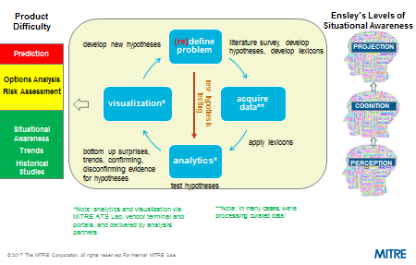

For more information, please contact:

Tom Carroll

Sr. Principal

The MITRE Corporation

Center for National Security

7515 Colshire Drive

McLean, VA 22102

703 983 7810

[cid:image001.png@01D0A90C.2B5B2680](https://www.facebook.com/MITREcorp)[cid:image002.png@01D0A90C.2B5B2680](https://www.linkedin.com/company/mitre)[cid:image003.png@01D0A90C.2B5B2680](https://twitter.com/MITREcorp)[cid:image004.png@01D0A90C.2B5B2680](https://www.youtube.com/user/mitrecorp)[cid:image005.png@01D0A90C.2B5B2680](https://plus.google.com/+MitreOrgFFRDCs/posts)

[cid:image006.png@01D0A90C.2B5B2680](http://www.mitre.org/)